TDC Sample Paper Two

Physics
Written Paper Stage 2A
Question/Answer Booklet

Student Number: In figures

In words

Student name: ____________________________________ Teacher name: _________________

Time allowed for this paper
Reading time before commencing work: Ten minutes
Working time for paper: Two and a half hours

Material required/recommended for this paper

To be provided by the supervisor
This Question/answer booklet; Formulae and constants sheet

To be provided by the candidate
Standard items: pens, pencils, eraser or correction fluid, ruler, highlighter
Special items: scientific non-programmable calculator

Important note to candidates
No other items may be taken into the examination room. It is your responsibility to ensure that you do not have any unauthorised notes or other items of a non-personal nature in the examination room. If you have any unauthorised material with you, hand it to the supervisor before reading any further.

All calculations are to be set out in detail. Marks may be awarded for correct equations and clear setting out, even if you cannot complete the calculation. Express numerical answers to two (2) or three (3) significant figures and include units where appropriate.
Student Marks
Section |  | Maximum mark | Student mark Raw | Student Scaled Mark
Section One  15 - 20 questions | Short Answer  40% of exam | 45 |  | out of 40
Section Two  5 – 7 questions | Problem Solving  50% of exam | 45 |  | out of 50
Section Three  1 -2 questions | Comprehension  10% of exam | 20 |  | out of 10
Student Percentage
Structure of this paper

Section of exam | Suggested working time | Number of questions | Number of questions to be attempted | Marks available
Section One | 60 minutes | 16 | all | 45
Section Two | 75 minutes | 5 | all | 45
Section Three | 15 minutes | 1 | all | 20
 | 150 minutes |  | [Total marks] | 110

Instructions to candidates

- The rules for the conduct of WACE examinations are detailed in the Student Information Handbook. Sitting this examination implies that you agree to abide by these rules.
- Answer all questions in the spaces provided in this Question/Answer Booklet. Answers should be given to the appropriate number of significant figures.
- A blue or black ballpoint or ink pen should be used.
- You must be careful to confine your responses to the specific questions asked and to follow any instructions that are specific to a particular question.
- Spare pages are included at the end of this booklet. They can be used for planning your responses and/or as additional space if required to continue an answer.
  - Planning: If you use the spare pages for planning, indicate this clearly at the top of the page.
  - Continuing an answer: If you need to use the space to continue an answer, indicate in the original answer space where the answer is continued, i.e. give the page number. Fill in the number of the question(s) that you are continuing to answer at the top of the page.

Section one: Short answer 40% (45 marks)

This section has sixteen (16) questions. Answer in the spaces provided.

Suggested working time: 60 minutes.

Question 1 (4 marks)

In an experiment on scalar and vector quantities, student 1 throws a ball 3.20 m east to student 2. Student 2 then it 4.50 m west to student three. The students then measured the distance and displacement of the ball.

a. Calculate the distance the ball travelled? [1 mark]

b. Draw a diagram then determine the ball’s displacement. [3 marks]

Question 2 (3 marks)

Two atoms are shown below. Both have mass number 60, but atom ONE has atomic number 28 while atom TWO has atomic number 27. Use this information to fill in the table below:

atom | Nuclide of atom | Number of neutrons | Number of protons
ONE
TWO

Question 3 (2 marks)

Alan is riding his bike along the road. At one point, he needs to apply the brakes to avoid hitting a child crossing the road. On the diagram show and label all the forces acting as he brakes.

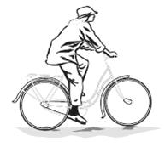

Question 4 (3 marks)

A passenger jet took 3.55 hours to travel from one city to another. If the jet travelled at a constant speed of 845 km h⁻¹, calculate the distance the jet travelled. Assume no air resistance.

Question 5 (3 marks)

A ride at the park involves raising a platform, to which the riders are strapped, up a height of 30.0 m. The platform is then allowed to freefall until it is brought to a rapid stop near the ground. If the riders and platform have a mass of 2.60 x 10³ kg what would be the apparent weight of rider and platform if the platform decelerated at a rapid 12.4 m s⁻² just before it reached the ground. [3 marks]

Question 6 (2 marks)

An unknown radioisotope has an activity of 15.00 g. The original activity of the sample was 8.00 kBq. If the half life of the sample was four days, calculate the activity 12.0 days later. [2 marks]

Question 7 (3 marks)

Identify “X” in each of the following equations and place its symbol in the brackets to the right of the equation. Name what is produce and if a type of radiation, name the radiation not the particle.

a. 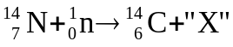 [ ] __________________________

b. 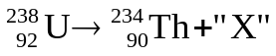 [ ] __________________________

c. 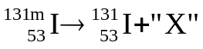 [ ] __________________________

(note: m denotes in excited state)

Question 8 (1 marks)

Which of the following would you choose to illustrate Newton’s first law of motion?
I A piece of stone tied to a cord is whirled in a circle. When the cord suddenly breaks, the stone flies off tangentially.
II An object falling freely has a uniform acceleration.
III The passengers in a bus lean forward when the driver applies the brakes.

A. I only
B. II only
C. III only
D. I and III only
E. All of them. Answer: __________

Question 9 (1 mark)

A student put a hot piece of toast on a cool, dry plate and then lifted it off. She saw drops of water on the plate in the area that had been covered by the toast. She thought that the water came from moisture, evaporated from the toast, which had condensed on the plate.

Which one of the following would help the student by supporting or rejecting her hypothesis? Only one answer is correct.

- Measuring the temperature of the plate before and after the toast was on it.

- Weighing the toast before and after it was on the plate.

- Measuring the temperature of the toast before and after it was on the plate.

- Weighing the plate before and after the toast was on it.

Answer: _________________

Question 10 (3 marks)

A child is playing with his new remote control car. The graph below shows part of the journey.
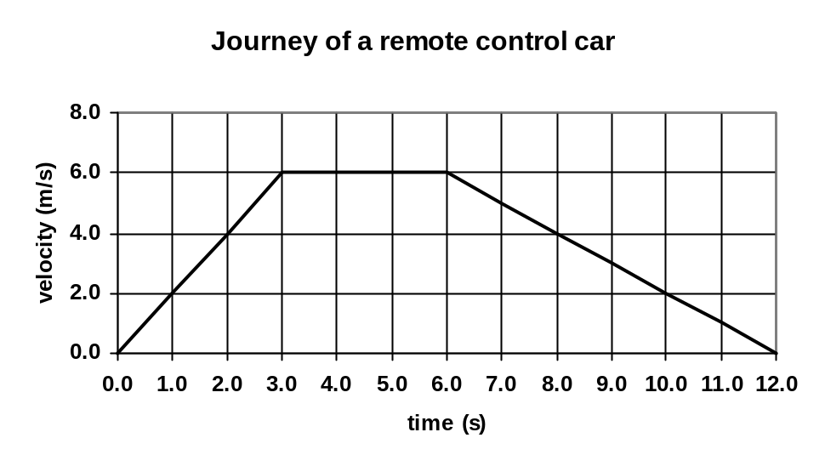
Calculate the displacement of the car over 12.0 seconds.

Question 11 (3 marks)

While standing on a first storey balcony, a child drops a 155 g ball to the group 4.20 m below. Calculate the kinetic energy gained by the ball as it hits the ground.

Question 12 (3 marks)

A shooter places the butt plate of a rifle against his shoulder before firing. He fires the rifle and it jerks back into his shoulder causing a bruise. By naming and using physics principles, explain why this happens.

__________________________________________________________________________________________________________________________________________________________________________________________________________________________________________________________________________________________________________________________________________________________________________________________________________________________________________________________________________________________________________________________________________________________________________________________________________________________________________________________________________________________________________________________________________________________________________________________________________________________________________
__________________________________________________________________________________________________________________________________________________________________
Question 13 (4 marks)

Ben is out riding his dirt bike. The bike’s engine can provide energy at the rate of 45.0 kW.

  - Calculate the amount of energy that the engine would supply to the bike in 60.0 seconds.
[2 marks]

  - Calculate the bike’s maximum average velocity against a total resistance force of 3.25 x 10³ N.
[2 marks]

Question 14 (3 marks)

A 145.0 g cricket ball is travelling north at 29.0 m s⁻¹ when it is hit and then travels 23.0 m s⁻¹ south. Calculate the cricket ball’s change in momentum when it was hit.

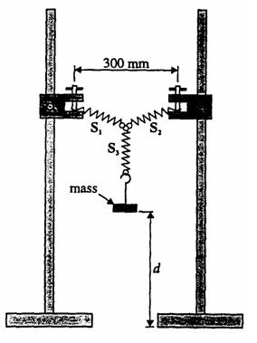
Question 15 (3 marks)

You can calculate the spring constant for a spring in a school laboratory by placing a mass on a spring in a similar set-up to that shown.

The mass can then be oscillated and the time for 10 oscillations taken. After repeating the trial, more mass is added and then the experiment is repeated. The spring constant, k, can then be calculated using the relationship.

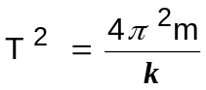

A group of students completed the experiment using the equipment set up similar to that shown. They took the appropriate measurements, recorded them and produced the graph below.
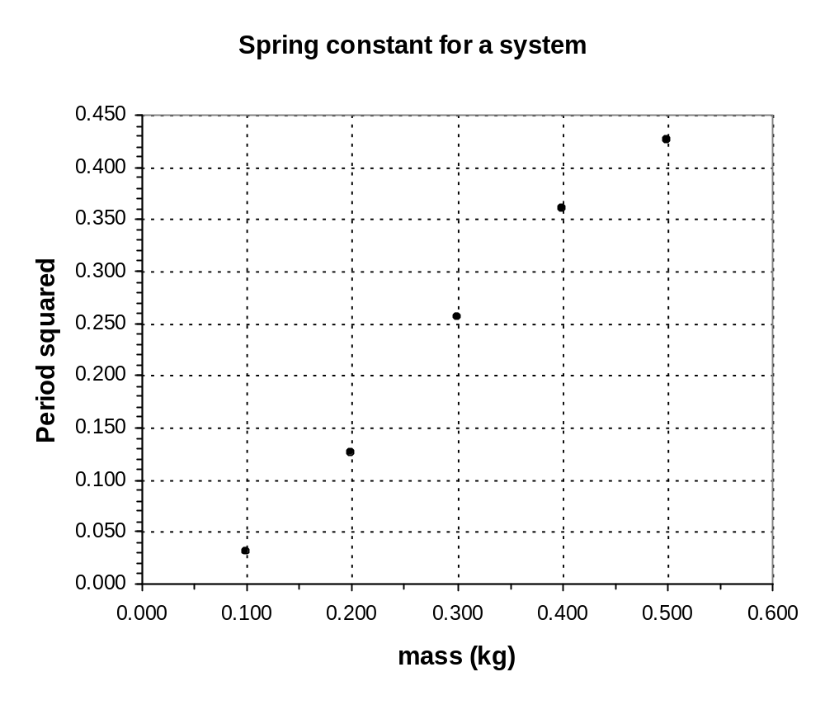
period squared (s²)
a. Complete the graph by drawing a line of best fit. [1 mark]

b. Calculate the period for a mass of 0.25 kg? [2 marks]

Question 16 (5 marks)

After an animal dies it no longer takes in Carbon-14, so that the ratio of C-14 (radioactive) to C-12 (not radioactive) gradually decreases. C-14 undergoes β-decay and has a half-life of about 5730 years. The decay rate of C-14 in a living animal is around 15 decays/minute per gram of carbon. An archaeologists finds what he thinks is a dinosaur bone. The bone has a mass of 425 g of carbon. The β-decay rate from the whole bone is 50 decays/minute. What is the approximate age of the bone and based on this information, do you think the archaeologist has a dinosaur bone (dinosaurs died out about 65 million years ago)?

Section two: Problem-solving 50% (45 marks)

This section has five (5) questions. Answer in the spaces provided.

Suggested working time: 75 minutes.

Question 17 (9 marks)

A cricket ball with a mass of 160.0 g is travelling horizontally with a velocity of 28.0 m s⁻¹ when it strikes another player’s helmet. The ball is brought to rest in 0.500 x 10⁻³ s.

  - Determine the total impulse the ball delivers to the helmet? [2 marks]

  - Calculate the ball’s acceleration on hitting the helmet? [2 marks]

  - Calculate the average force the ball exerts on the helmet? [2 marks]

  - Determine the work done on the ball by the helmet to bring it to a halt? [3 marks]

Question 18 (6 marks)

The diagram below shows the merging lane of the on-ramp of a busy freeway. A set of traffic lights is installed at X, 4.00 x 10² m from Y where the cars merge into the traffic flow. The vehicles on the busy freeway are travelling at a constant speed of 90.0 km h^{–1}. When car A, a distance d along the road from point Y, is at the position shown, the traffic light at X changes to green. Car B, at the traffic light, is then expected to uniformly accelerate to 90.0 km h^{–1} at Y and merge into traffic beside car A. Calculate the distance d. (You must show your working.)
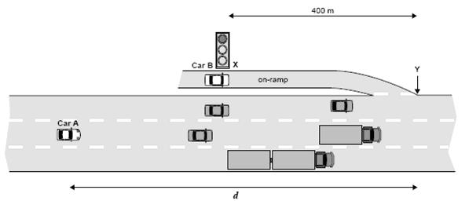
Question 19 (9 marks)

A remote control car moves along a straight line. Its displacement from the starting point is shown as a function of time.
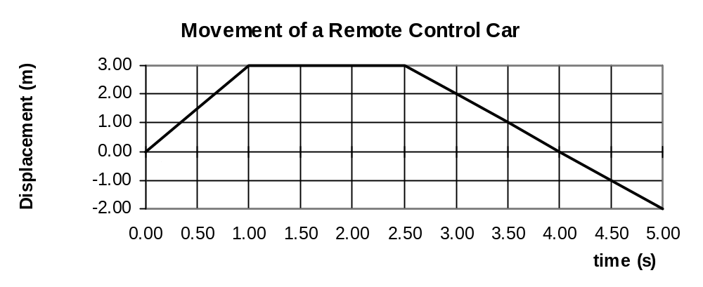
- Determine the displacement of the object at 5.00 s? [1 mark]

- Which section or sections of the graph represents a constant velocity of 3.00 ms⁻¹? You must include calculations to justify your answer. [2 mark]

- Which section of the graph represents the object at rest? [1 mark]

- Determine the velocity for section C-D? [2 marks]

- Determine the time elapsed before the car returned to its starting point? [1 mark]

- Sketch a velocity/time graph of the journey. [2 marks]

Question 20 (12 marks)
Within a nuclear power plant, uranium-235 can undergo fission according to the equation.

- Calculate the energy in joules that would be released from the complete fission of one uranium atom. [4 marks]

- Determine the amount of energy released per kilogram of uranium atoms? [2 marks]

- Another nuclear reaction is that which occurs in the Sun.
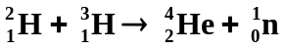
Calculate the energy released in MeV for one such reaction. [3 mark]

- Safety is a big issue in nuclear power stations and all employees must wear a film badges that registers the amount of radiation they have received each month. Film badges have a photographic film enclosed within an opaque plastic case that is sensitive to both gamma and beta radiation. While the amount of beta radiation they receive is not a problem, the amount of gamma is and a film badge must be able to show the difference. Using your understanding of the characteristics of beta and gamma radiation, explain how the film badge could be made to show the difference between the amount of beta and gamma radiation the employee had received that month. [3 marks]

_____________________________________________________________________________
_____________________________________________________________________________
_____________________________________________________________________________
_____________________________________________________________________________
_____________________________________________________________________________
_____________________________________________________________________________
_____________________________________________________________________________
_____________________________________________________________________________
_____________________________________________________________________________
_____________________________________________________________________________
_____________________________________________________________________________
_____________________________________________________________________________
_____________________________________________________________________________
_____________________________________________________________________________
_____________________________________________________________________________
_____________________________________________________________________________
_____________________________________________________________________________
_____________________________________________________________________________
_____________________________________________________________________________
_____________________________________________________________________________
_____________________________________________________________________________
_____________________________________________________________________________
_____________________________________________________________________________
_____________________________________________________________________________
Question 21 (8 marks)

An industrial physicist accidentally swallows a radioisotope with an activity of 10.0 kBq. The material swallowed has a very long half-life. You can assume therefore that the activity will not change appreciably during the physicist’s lifetime. Each decay of the isotope releases 1.60 x 10⁻¹³ J of energy into his body and that the radioisotope is not eliminated from the body.

a. Calculate the amount of energy absorbed in one year. (1 year = 365 days) [3 marks]
(If you are unable to do this part, use the value 0.100 J to continue this question.)

- If the physicist has a mass of 70.0 kg, calculate the absorbed dose in one year. [2 marks]

Some types of absorbed radiation are potentially more damaging than others. For example, a particular absorbed dose of α radiation is much more damaging to the cells of the body than the same dose of β or γ radiation. To take this into account the absorbed dose is multiplied by an extra weighting called the Quality Factor (QF). Assuming that the ingested radioisotope is an alpha emitter. (QF = 20),

- What is the dose equivalent absorbed per year? [2 mark]

- Should the physicist be concerned about this yearly radiation exposure? Explain. [1 marks]
____________________________________________________________________________
____________________________________________________________________________
____________________________________________________________________________
_____________________________________________________________________________
Section three: Comprehension 10% (20 marks)

This section has one (1) question. Answer in the spaces provided.

Suggested working time: 20 minutes.

Question 22 (20 marks)

In a Physics investigation, a group of students measures the time (t) for a trolley to roll down a 5.0 m incline starting the trolley from rest. The slope is determined by raising one end of the plank by distance H. After repeating the measurement four times, the students then increases the slope of the incline, and repeats the timing procedure for the trolley to cover the same distance. The students repeats the exercise for four other slopes, the results of which are recorded in the table below.

Height | Time for the trolley to roll down the slope  t (s)
H (cm) | t₁ | t₂ | t₃ | t₄ | Average
20 | 5.2 | 5.1 | 4.9 | 5.0
30 | 4.2 | 4.0 | 4.1 | 4.1
40 | 3.6 | 3.5 | 4.2 | 3.5
50 | 3.2 | 3.1 | 3.2 | 3.1
60 | 2.9 | 2.85 | 2.9 | 2.1

State the independent and dependent variables for this experiment. [2 marks]
  - Independent: __________________________________
  - Dependent: ___________________________________

- List TWO control variables to make it a fair test. [2 marks]
______________________________________________________________________________________________________________________________________________________________________________________________________________________________________________________________________________________________________________________________________________________________________________________________________
- Explain why the students repeated the trials four times before changing the height. [2 marks]
________________________________________________________________________________________________________________________________________________________________________________________________________________________________________________________________________________________________________________________
Now regarding the data:

Circle any of the results you would disregard when finding the average of the results. [1 marks]
- Explain why you would disregard these results and if it is acceptable to do so. [2 marks]
__________________________________________________________________________________________________________________________________________________________________________________________________________________________________________________________________________________________________________________________________________________________________________________________________________________________________________________________________________________________________________________________________________________________________________________________________________________________________________________________________________________________________________________________________________________________________________________________________________________________________________________________________________________________
- Complete the table above by calculating the averages. [3 mark]
- Plot a graph of H against t on the graph paper on page 21. [5 marks]
- Write a conclusion for this investigation based on the data collected and the graph. [2 marks]
_______________________________________________________________________________________________________________________________________________________________________________________________________________________________________________________________________________________________________________________________________________________________________________________________________________________________________________________________________________________________________________________________________________________________________________________________________________________________________________________________________________________________________________________________________________________________________________________________________________________________________________________________________________________________________________________________________________________________________

END OF EXAMINATION

_____________________________________________________________________________________________________________________________________________________________________________________________________________________________________________________________________________________________________________________________________________________________________________________________________________________
_____________________________________________________________________________________________________________________________________________________________________________________________________________________________________________________________________________________________________________________________________________________________________________________________________________________
_____________________________________________________________________________________________________________________________________________________________________________________________________________________________________________________________________________________________________________________________________________________________________________________________________________________
_____________________________________________________________________________________________________________________________________________________________________________________________________________________________________________________________________________________________________________________________________________________________________________________________________________________
_____________________________________________________________________________________________________________________________________________________________________________________________________________________________________________________________________________________________________________________________________________________________________________________________________________________
_____________________________________________________________________________________________________________________________________________________________________________________________________________________________________________________________________________________________________________________________________________________________________________________________________________________
_____________________________________________________________________________________________________________________________________________________________________________________________________________________________________________________________________________________________________________________________________________________________________________________________________________________
_____________________________________________________________________________________________________________________________________________________________________________________________________________________________________________________________________________________________________________________________________________________________________________________________________________________
_____________________________________________________________________________________________________________________________________________________________________________________________________________________________________________________________________________________________________________________________________________________________________________________________________________________
_____________________________________________________________________________________________________________________________________________________________________________________________________________________________________________________________________________________________________________________________________________________________________________________________________________________
_____________________________________________________________________________________________________________________________________________________________________________________________________________________________________________________________________________________________________________________________________________________________________________________________________________________
__________________________________________________________________________________________________________________________________________________________________

